AIEEE Previous Years Papers Solutions
AIEEE Paper > 2007-Mathematics Solutions

AIEEE 2007 Mathematics Answers and Solutions
___________________________________________________________________
ANSWERS
1) 4 | 2) 2 | 3) 4 | 4) 3
5) 4 | 6) 3 | 7) 4 | 8) 2
9) 1 | 10) 3 | 11) 4 | 12) 3
13) 2 | 14) 1,4 | 15) 3 | 16) 1
17) 2 | 18) 2 | 19) 4 | 20) 4
21) 1 | 22) 2 | 23) 3 | 24) 2
25) 4 | 26) 3 | 27) 3 | 28) 4
29) 1 | 30) 4 | 31) 3 | 32) 1
33) 3 | 34) 1 | 35) 3 | 36) 4
37) - | 38) 1 | 39) 3 | 40) 3
Some Important Hints and Solutions:
1. n^{th} term of the Geometric progression = a_{n} = ar^{n-1}
So, ar^{n-1} = ar^{n} + ar^{n+1}
=> i = r + r²
=> r = 1/2(√5 - 1)

2. sin⁻¹(x/5) + cosec⁻¹(5/4) = π/2
=> sin⁻¹(x/5) = π/2 - cosec⁻¹(5/4) = π/2 - sin⁻¹(4/5)
=> sin⁻¹(x/5) = cos⁻¹(4/5) = sin⁻¹(3/5)
=> x = 3

3. ^{n}C₄ a^{n-4}(-b)⁴ + ^{n}C₅ a^{n-5}(-b)⁵ = 0
=> a/b = (n-5+1)/5 = (n-4)/5

4. Number of ways to partition : ¹²C₄ x ⁸C₄ x ⁴C₄ = 12!/(4!)³

5. x/2 - 1 must be between -1 and 1 , so
-1 ≤ x/2 - 1 ≤ 1 .......... (i)
and, cosx must be greater than 0, i.e
cosx > 0 ..................(ii)
By solving (i), 0 ≤ x ≤ 4
By solving (ii), π/2 < x < -π/2
So, x ∈ [ 0 , π/2 )

6.
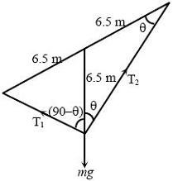
T₂cosθ +T₁sinθ = mg .....................(i)
T₂sinθ = T₁cosθ .....................(ii)
T₂ = mgcosθ .....................(iii) By solving (ii) and (iii)
T₁ = mg sinθ
tanθ = 5/12
So, T₁ = 13kg x (5/13) = 5 Kg
And, T₂ = 13kg x (12/13) = 12 Kg
7. Probability of getting score 9 in a single throw = 4/36 = 1/9
Probability of getting sum nine exactly two times out of three draws = ³C₂ (1/9)²(8/9) = 8/243

8. Equation of circle is: (x-h)² + (y-k)² = k²
The circle passes thru (-1,1), so
(-1-h)² + (1-k)² = k²
h² + 2h -2k + 2 = 0
D ≥ 0
2k-1 ≥ 0
⇒ k ≥ 1/2

9. If direction cosines of L be l, m, n, then
2l + 3m + n = 0 ............(i)
l + 3m + 2n = 0 ............(ii)
By solving (i) and (ii)
l/3 = -m/3 = n/3
So, l:m:n = 1/√3 : -1/√3 : 1/√3
So, cosα = 1/√3

10. Equation of circle passing through origin and having their centres on x-axis is :
x² + y² + 2gx = 0 ............ (1)
2x + 2y dy/dx + 2g = 0
Replacing value of g from equation (i)
y² = x² + 2 xy dy/dx

11. We know that:
Arithmetic Mean ≥ Geometric Mean. So
(p² + q²)/2 ≥ pq
=> 1/2 ≥ pq
=> 1 ≥ 2pq
We know that
p² + q² + 2pq = (p+q)²
1 + 1 ≥ (p+q)²
=> √2 ≥ (p+q)

12.
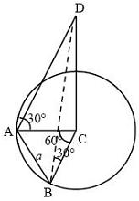
∠ACB = 60°
ΔABC is an equilateral triangle
Radius of the circle = a
DC/AC = tan30°
DC = a/√3

13. (1+x)²⁰ = ²⁰C₀ + ²⁰C₁x + ²⁰C₂x² + .... + ²⁰C₂₀x²⁰
Let x = -1, then
0 = ²⁰C₀ - ²⁰C₁ + ²⁰C₂ + .... + ²⁰C₂₀
0 = 2(²⁰C₀ - ²⁰C₁ + ²⁰C₂ + .... - ²⁰C₉) + ²⁰C₁₀
²⁰C₀ - ²⁰C₁ + ²⁰C₂ + .... - ²⁰C₉ + ²⁰C₁₀ = (1/2)²⁰C₁₀
14. Equation of normal at P(x,y) is : Y-y = (dy/dx) (X-x)
Co-ordinate of point G is (x+y(dy/dx) , 0)
|x+y(dy/dx)| = 2x ................ (i)
=> y(dy/dx) = x OR y(dy/dx) = -3x
=> y dy = x dx OR ydy= -3xdx
=> y²/2 = x²/2 + c OR y²/2 = -3x²/2 + c
=> x² - y² = -2c OR 3x² + y² = 2c

15.
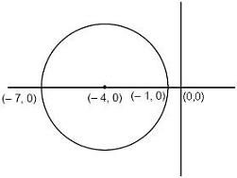
|z + 4| ≤ 3
=> z can be on the circle or inside the circle of radius=3 and center at: (-4,0).
=> So maximum value of |z+1| will be 6

16.
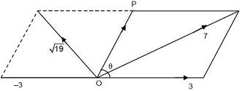
7² = P² + 9 + 6Pcosθ
=> 6Pcosθ = 40 - P² ............................(i)
19 = P² + 9 + 6Pcos(π - θ)
=> 19 = P² + 9 - 6Pcosθ ............................(ii)
Solving (i) and (ii)
19 = P² + 9 - 40 + P²
So, P = 5N

17. Required probability = 0.7 x 0.2 + (0.7) (0.8) (0.7) (0.2) + (0.7) (0.8) (0.7) (0.8) (0.7) (0.2) + ...
= 0.14 [ 1 + (0.56) + (0.56)² + (0.56)³ + (0.56)⁴..... ]
= 0.14 (1/(1-0.56)) = 0.14/0.44 = 7/22

18.
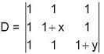
Do following:
Column3 = Column3 - Column1
Column2 = Column2 - Column1
So,
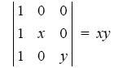
So, D is divisible by x and y.

19. Eccentricity: Eccentricity measures as how much the conic section deviates from being circular.
a² = cos²α ................(i)
b² = sin²α ................(ii)
b² = a²(e² - 1) ................(iii)
By solving (i), (ii) and (iii)
e = secα
coordinates of focii : (±ae , 0) = (±1 , 0)
Hence abscissae of foci remain constant when α varies.

20. cos²α + cos²β + cos²γ = 1
=> cos²π/4 + cos²π/4 + cos²γ = 1
=> 1/2 + 1/2 + cos²γ = 1
=> cos²γ = 0
=> γ = π/2

21. f'(C) = (f(3)-f(1))/(3-1)
=> 1/c = (log_{e}3)/2
=> c = 2log₃e
22. f(x) = tan⁻¹(sinx + cosx)
f'(x) = (cosx - sinx)/( 1+(sinx + cosx)² )
f'(x) = (√2 cos(x+π/4))/( 1+(sinx + cosx)² )
So, f(x) increases if -π/2 < x + π/4 < π/2
=> So, f(x) increases if -3π/4 < x < π/4
=> So f(x) increases in x ∈ (-π/2 , π/4)

23.
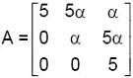
|A . A| = |A|.|A| = (25α). (25α) = 25
So, α² = 1/25
=> α = ± 1/5

24. e^{-x} = 1 - x + X²/2! - x³/3! + x⁴/4! - .......
Repace x with 1, then
1/2! - 1/3! + 1/4!..... = e⁻¹

25. |2u × 3v| = 1
6|u × v| = 1
|u × v| = 1/6
sinθ = ±1/6
As θ is accute angle so θ can have only value

26.
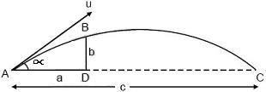
a = u cosα t ................... (i)
b = u sinα t - 1/2 gt² .........................(ii)
c = (u² sin2α)/2 ..............................(iii)
Using (i) and (ii)
b = a tanα - (1/2)g (a²)/(u²cos²α) .........(iv)
Repacing value of u² from (iii) in (iv)
b = (a tanα) - (a²g sin2α sec²α)/(2cg)
Use, sin2α = 2sinα cosα
b = a tanα - (a² 2tanα)/(2c)
tanα = (bc)/(a(c-a))

27. Let number of boys = x
number of girls - y
Total marks = 52x + 42y = 50 (x+y)
=> 2x = 8y
=> x = 4y
So percent of boys = 100x/(x+y) = 400y/(5y) = 80%

28. Point of intersection of two perpendicular tangents to the parabola must be on directrix of the parabola.
Equation of directrix is
x + 2 = 0
Hence the point is (-2, 0).

29. Coordinates of centre = (3,6,1)
Let coordinates of other end of the diameter is (α, β, γ)
So,
(α+2)/2 = 3
(β+3)/2 = 6
(γ+5)/2 = 1
So, α = 4
β = 9
γ = -3

30.
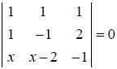
By solving above ,
2x + 4 = 0
x = -2
31.
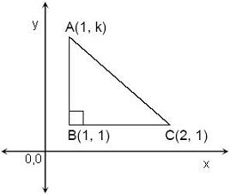
A = (1/2).1.|k-1| = 1
=> k-1 = 2 OR k-1= -2
=>k = 3 OR k = -1
32.
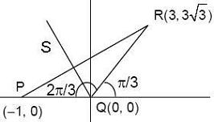
Slope of QR = √3
So ∠PQR = 120°
Slope of QS = tan120° = -√3
So equation of QS will be
y=-√3 x

33. my² + (1 - m²)xy - mx² = 0
=> my² + m²xy + xy - mx² = 0
=> my(y-mx)+x(y-mx) = 0
=> (my+x)(y-mx) = 0
=> y=mx and y=(-1/m)x
So, m=±1

34.
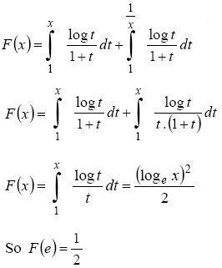
35.
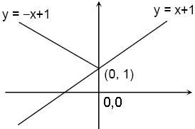
f(x) = Min { x + 1 , |x| , 1 }
(under progress)

40. α+β=-a
and α.β=1
|α-β| < √5
=> (α-β)² < 5
=> (α+β)² - 4α.β < 5
=> a²-4 < 5
=> a ∈ (-3,3)

